CODE:
DBConnection.java:
import java.sql.Connection;
import java.sql.DriverManager;

public class DBConnection {

public static Connection getConnection() {

Connection con = null;

try {

Class.forName("com.mysql.cj.jdbc.Driver");

String url = "jdbc:mysql://localhost:3306/bankdb";
String username = "root";
String password = "root";

con = DriverManager.getConnection(url, username, password);

System.out.println("Connected to MySQL Successfully!");

} catch (Exception e) {

System.out.println("Connection Failed!");
e.printStackTrace();

}

return con;
}

public static void main(String[] args) {

Connection con = getConnection();

if (con != null) {
System.out.println("Database Connection Established.");
}

}
}
ProcessMonthlyInterest.java:
import java.sql.*;

public class ProcessMonthlyInterest {

public static void main(String[] args) {

try {

Connection con = DBConnection.getConnection();

String query = "UPDATE ACCOUNT SET Balance = Balance + (Balance * 0.01) WHERE AccountType='Savings'";

PreparedStatement ps = con.prepareStatement(query);

int rows = ps.executeUpdate();

System.out.println(rows + " accounts updated successfully.");

con.close();

}

catch(Exception e){

e.printStackTrace();

}

}

}
OUTPUT:
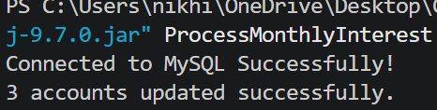
TransferFunds.java:

import java.sql.*;
import java.util.Scanner;

public class TransferFunds {

public static void main(String[] args) {

Scanner sc = new Scanner(System.in);

try {

Connection con = DBConnection.getConnection();

con.setAutoCommit(false);

System.out.print("Enter Source Account : ");
int source = sc.nextInt();

System.out.print("Enter Destination Account : ");
int destination = sc.nextInt();

System.out.print("Enter Amount : ");
double amount = sc.nextDouble();

String check = "SELECT Balance FROM ACCOUNT WHERE AccountID=?";

PreparedStatement ps = con.prepareStatement(check);

ps.setInt(1, source);

ResultSet rs = ps.executeQuery();

if(rs.next()){

double balance = rs.getDouble("Balance");

if(balance >= amount){

PreparedStatement withdraw = con.prepareStatement(
"UPDATE ACCOUNT SET Balance=Balance-? WHERE AccountID=?");

withdraw.setDouble(1, amount);
withdraw.setInt(2, source);

withdraw.executeUpdate();

PreparedStatement deposit = con.prepareStatement(
"UPDATE ACCOUNT SET Balance=Balance+? WHERE AccountID=?");

deposit.setDouble(1, amount);
deposit.setInt(2, destination);

deposit.executeUpdate();

con.commit();

System.out.println("Transfer Successful.");

}

else{

System.out.println("Insufficient Balance.");

con.rollback();

}

}

con.close();

}

catch(Exception e){

e.printStackTrace();

}

}

}
OUTPUT:
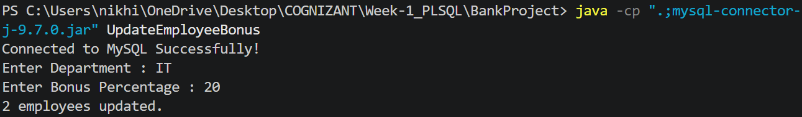
UpdateEmployeeBonus.java:
import java.sql.*;
import java.util.Scanner;

public class UpdateEmployeeBonus {

public static void main(String[] args) {

Scanner sc = new Scanner(System.in);

try {

Connection con = DBConnection.getConnection();

System.out.print("Enter Department : ");
String dept = sc.nextLine();

System.out.print("Enter Bonus Percentage : ");
double bonus = sc.nextDouble();

String query =
"UPDATE EMPLOYEE SET Salary = Salary + (Salary * ? /100) WHERE Department=?";

PreparedStatement ps = con.prepareStatement(query);

ps.setDouble(1, bonus);
ps.setString(2, dept);

int rows = ps.executeUpdate();

System.out.println(rows + " employees updated.");

con.close();

}

catch(Exception e){

e.printStackTrace();

}

}

}
OUTPUT: 